Abstract
The most highly respected medical journals have argued that pollution is not a problem in the United States. Beelen et al. (2014) provided a map suggesting that pollution in North America is not a problem. Moreover, Chetty et al. (2016) made the same claim in JAMA (Journal of the American Medical Association), arguing no measurable impact of pollution on lifespan. This article shows, with new maps and tables from government sources along with unauthorized leaked data, that pollution is a major problem in the United States and has many harmful health impacts that are largely ignored in health and medical journals. The United States is one of the largest polluters in the world and one of the largest emitters of greenhouse gases, emitting 15% of the world’s greenhouse gases while representing only 5% of the world’ population. Pollution in over 1,000 places in the United States hurts lifespan, health, prosperity, and sustainability. This is not given enough attention in the literature.

It’s going to get worse. Look around you, and you’ll see that no place is safe from the ravages of climate chaos. Every state has experienced the pain of climate chaos—Hawaii, Florida, New York, Arizona, and California. East to West, and North to South, we are witnessing the slow destruction of the Earth as we once knew it. Look around the world—North Pole, Middle East, China, Russia, Africa, and South America. We have a climate crisis that is destroying our way of life with record high temperatures. We are facing a catastrophic crisis that will destroy the Earth as we know it in eight years, according to the United Nations.
The following media reports from 2022 to 2025 paint a frightening picture of climate change and the future of the planet. A lot of it has to do with greenhouse gases, like carbon dioxide and methane, which trap heat in the Earth's atmosphere, leading to global warming. Have we finally reached a tipping point in our civilization at which people will say, “Enough!”?
- LA firefighters battle to contain monster inferno as death toll rises (BBC, January 11, 2025)
- Man found dead in car amid 126-degree heat in Death Valley National Park (Fox Weather, July 6, 2023)
- Extreme weather event, resulting in flash flooding leading to over 205 deaths in Valencia, Spain (The New York Times, November 1, 2024)
- Extreme heat wave bound for Phoenix and Southwest could be worst ever (Washington Post, July 7, 2023)
- How hot is South Florida? Beach sand was 137 degrees and playground floor reached 177 (Miami Herald, August 10, 2023)
- Earth hit an unofficial record high temperature this week (AP News, July 5, 2023)
- East Palestine train derailment killed more than 43,000 fish and animals, officials say (USA Today, February 24, 2023)
- Nearly 2 billion at risk from “unprecedented” climate conditions (Axios, May 23, 2023)
- South Florida Ocean Temperature Tops 101 Degrees Fahrenheit, Potentially a Record (CNBC, July 25, 2023)
- Venice faces an Unwelcome Honor: Joining the Endangered Places List (The New York Times, August 1, 2023)
- Iran Begins Two-Day Shutdown as Heat Wave Worsens to 140 degrees (Wall Street Journal, August 2, 2023)
- Maui wildfire death toll, already highest in modern U.S. history with 117 found dead and 350 still missing many presumed to have drowned, could surge (NBC News, August 18, 2023)
- The wildfire caused destruction or damage to 2,200 structures, with 86 per cent of them being residential in West Maui. The losses approach $6 billion (Spectrum News, August 13, 2023)
- Earth is at its hottest in thousands of years (Washington Post, July 8, 2023)
- For Millions in Mexico City, Water is Disappearing: Drought and Sprawl Push Resources to the Brink (The New York Times, May 19, 2024)
- At least 95 are dead from the Hurricane in Six Coastal states from Florida to North Carolina; knocking out power to millions and trapping families in floodwaters. (CNN September 29, 2024)
- The world’s top medical journal, The Lancet, found in a review of over 400 studies that places with high pollution are responsible for 9 million premature deaths annually (Beelen et al., 2014)
- “One third of Pakistan underwater, 1,700 people killed” (Al Gore’s speech at the United Nations Climate Change Conference [COP27], November 7, 2022)
- “A heatwave in China that lasted 70 days with the heat above 40 degrees, 104 Fahrenheit, over a vast area of China” (Al Gore’s speech at the United Nations Climate Change Conference [COP27], November 7, 2022)
- “Another million displaced in Nigeria two weeks ago, another million in Chad a few days after that” (Al Gore’s speech at the United Nations Climate Change Conference [COP27], November 7, 2022)
- “Droughts are drying up the mighty Mississippi River . . . the Tigris and the Euphrates in the cradle of civilization, the Po River in Italy, Loire in France, the Rhine in Germany” (Al Gore’s speech at the United Nations Climate Change Conference [COP27], November 7, 2022)
- Jakarta, Indonesia is the world’s most polluted city—the sea is rising so high the entire capital is being moved to higher ground (CNN, August 16, 2023)

Pollution is a Major Cause of Climate Chaos
Pollution is the number one killer, with an estimated 8 million premature deaths a year worldwide. However, pollution is not significantly linked as a major cause of global warming. Maps by Beelen et al. (2014) incorrectly show that the problem is mostly in China, Russia, and India. Nobody seems to know how North America got a pass, and this is at odds with the EPA findings and the research of Gilderbloom et al. (2020a; 2020b; 2022). The map by Beelen et al. (2014) showing deaths per 100,000 attributable to pollution was published by The Lancet, the leading medical journal in the world (Beelen et al., 2014). Notice in Figure 1 that North America, Australia, and Northern Europe get a pass for hardly any deaths being caused by pollution (Beelen et al., 2014). This goes against evidence produced by numerous academic and government statistics, and it needs to be corrected. Pollution might not cause as many deaths in the U.S. as in China and India, but the U.S. has a substantial number of pollution-related deaths. In at least one major city with lots of pollution, it accounts for nearly 60,000 deaths and health problems (cancer, asthma, and COPD) that are two to five times greater than in non-polluted areas.
A pre-publication of my article ranking the most dangerous toxic pollution in the United States appeared in The Lancet and was later published in a refereed journal and in my book, Climate Chaos: Killing People, Places, and the Planet. In a recent article I submitted to The Lancet, I asked the editor to correct the claim that pollution is not a problem in the United States. I included numerous figures, maps, and tables in the article, and The Lancet, instead of publishing it, forwarded it to a sister publication that wanted me to pay them $4,582 to publish it. I told The Lancet that I have never paid anyone to publish my articles, and I was not going to start now. I decided to submit my article to other publications (including this one) instead.
<INSERT FIGURE 1 HERE>
Chetty et al. (2014) found that in some parts of the U.S.A., some places have reduced lifespan, but he discounted pollution, which is consistent with The Lancet. Our research found otherwise—the rust belt has some of the highest levels of pollution and significantly reduced lifespan.
<INSERT FIGURE 2 HERE>
ProPublica identified 1,000 places around the United States in which dangerous toxins are released in the air. The majority are in the rust belt area and the South (Shaw and Younes, 2021). But they do not connect how these 1,000 places are linked to premature deaths, health problems, greater poverty, and climate warming. The map by Shaw and Younes (2021) shows concentrations of chemical releases mostly in the rust belt and sun belt but few along the East and West Coast.
<INSERT FIGURE 3 HERE>
<INSERT FIGURE 4 HERE>
My research team discovered an error in air pollution measuring: two of the four EPA measures of pollution were missing. We looked at a sample of 148-isolated cities with air quality ranging from clean to toxic. We wanted to develop a clean and unbiased accounting of which medium size cities have high levels of toxins and have a devastating impact on communities in the United States. Our selection of semi-isolated cities was based on those counties that had a population of 50,000 persons and were at least 20 miles or more from another county of 50,000 or more. Figure 5 shows the location of these 148 semi-isolated cities. We also wanted to separate mega cities like New York, Chicago, Los Angeles, Philadelphia, and San Francisco from more ordinary cities that are self-contained and semi-isolated. The New York City Region is about the size of Pennsylvania. In other words, comparing New York to Louisville is as ridiculous as comparing a mouse to an elephant. This method has been used in studies by Gilderbloom and Appelbaum (1987), Appelbaum (1978), Logan and Molotch (1987), and Gilderbloom (2008) to measure the pollution levels in U.S. cities. Figure 5 shows the cities that were selected.
<INSERT FIGURE 5 HERE>
The EPA has four basic measures of urban air quality: PM10 Particular Matter, PM2.5 (Particular Matter), NOx (Nitrogen Oxides), and S0x (Sulfur Dioxide). Measures PM 2.5 and PM10.0 were readily available, but NOx and SOx were not available until a graduate intern disclosed to us how to retrieve it. The graduate student disclosed to me that as a summer intern, he was told to destroy these measures or at least make them unavailable to scientists. He showed us how to get in the “backdoor” and retrieve them. It was complicated, and we later published a paper on it in The Lancet pre-prints (Gilderbloom et. al. 2020a; Gilderbloom et. al. 2022). We then grouped together these four measures and showed the results (Table 1), before further organizing them into the ten most polluted and ten least polluted midsized cities (Table 2). From this list, we chose to look at the second most polluted mid-sized city to examine why it is so polluted and what the possible health impacts might be. Having brought in 3.5 million dollars in competitive grants from EPA, HUD, DOE, the State Department, local foundations (Gheens and Miller), and state and local government, we were intimately familiar with Louisville’s record of pollution.
<INSERT TABLE 1 HERE>
<INSERT TABLE 2 HERE>
The first map (Figure 6) of Rubbertown chemical factories is produced by Louisville Air Pollution Control District. It is estimated by Gilderbloom et al. (2023) that the total pounds of toxic release into the West Louisville neighborhoods comes to 75,000 pounds—about 1.25 pounds per person. Figure 7 shows the amount of discharge in these West Louisville neighborhoods, which are mostly poor and 75% minority.
<INSERT FIGURE 6 HERE>
Another stark measure is the comparison between West Louisville neighborhoods near Rubbertown, U.S. averages, and the five cities with the cleanest air in the country. It appears that those who live nearest chemical plants have the worst medical problems compared to national averages or America’s cleanest cities—such as Santa Barbara, CA; Evansville, IN; and Columbus, GA.
A high level of diseases in polluted areas is also correlated with lower life expectancy by as much as ten years, according to Figure 8. Compared internationally, the lifespan of residents in West Louisville neighborhoods is lower than that of people living in Iraq, Jamaica, or Vietnam. Additionally, the overall lifespan of Louisvillians is five times shorter than that of residents in non-polluted West Coast cities like Santa Barbara and Santa Rosa (Gilderbloom et. al. 2022).
<INSERT FIGURE 8 HERE>
What Can We Do About Pollution?
Scientists widely agree that pollution is a source for causing harm to the heart, lungs, and brain, and a major pre-existing condition for contracting COVID-19 (Meares et al., 2021). We have the tools to reverse catastrophic climate crisis with commonsense pollution controls—not just slow it down by three to four years. KIESD (Kentucky Institute for the Environment and Sustainable Development) partnered with American Synthetic Rubber, which alone was responsible for the production of roughly 90% of a deadly cancerous causing chemical:1,3-butidiene. The former director of KIESD, Russ Barnett, found that when American Synthetic Rubber shut down for two weeks during the summer, the chemical was mostly non-detectable in the air. KIESD proposed a $3 million-dollar anti-pollution device that would stop 1,3-butidiene from being released in the air, water, and soil. Russ made a “good neighbor” proposal to have American Synthetic Rubber to install a $3 million-dollar device to forestall this dangerous pollutant that is highly correlated with cancer from going into the air. Imagine the positive impact if the chemical companies that produce 75,000 pounds of chemical pollutants were equipped with such devices. Moreover, our research pushed the EPA to reduce the amount of pollution by at least 6,000 pounds (Giffin, 2024; see also Gilderbloom, 2023). EPA officials tipped the hat to my series of articles on pollution in the local newspapers and academic journals, along with my research cited by the U.S. Department of Justice (2023; see also Gilderbloom, 2023, 2020a, 2020b, 2020c). Good measures of data help move officials to act.
How deadly are the toxins in Louisville? One accident, one angry employee, or one terrorist attack could wipe out thousands of lives in West Louisville with a chemical leak or explosion. This is a ticking time bomb. Given the relative density of West Louisville, roughly 60,000 residents could die instantly, according to former officials from the Commonwealth of Kentucky Energy and Environmental Cabinet, the recently closed KIESD, and the Center for Sustainable Urban Neighborhoods.
Contrary to the piece in The Lancet (Beelen et.al 2014), the United States is one of the biggest emitters of greenhouse gases in the world (Potsdam Institute for Climate Research via Climate Watch, 2025). As Nobel Peace Prize laureate Al Gore stated in his 2022 speech at the United Nations Climate Change Conference, “Today, as every day, we are spewing 162 million tons of man-made, heat-trapping, global-warming pollution into the sky. It adds up, accumulates, and lingers there. On average, each molecule lingers there for 100 years, and the accumulated amount adds up to as much as 600,000 Hiroshima-class atomic bombs exploding every day on our planet. That’s why we’re seeing these disasters, and the pattern is very clear. It’s getting steadily worse” (Gilderbloom, 2025: 459).
Historically, the United States has emitted more greenhouse gases than any other country. More recently, China led the world in emitting more greenhouse gases than any other country (Intergovernmental Panel on Climate IPCC, 2024; World Resources Institute, 2025). The United States emits the most greenhouse gases per capita (World Resources Institute, 2025), and China releases twice the amount of greenhouse gases released by the United States (Potsdam Institute for Climate Research via Climate Watch, 2025).
Scientists examined the ill effects of a toxic waste landfill that homes and schools were built on in a neighborhood called Love Canal, near Niagara Falls. Researchers showed the link between toxins in the soil and a host of health problems (Newman, 2020; Gill and Mix, 2020). This landfill site, discovered in 1977, was a major environmental disaster that prematurely killed residents and caused major health problems for hundreds of people. Hooker Chemical company used the site to dump 19,800 tons of chemical byproducts, dyes, perfumes, solvents for rubber, and synthetic resins.
My Experience as a UofL Professor Researching Deadly Pollution
In September 2024, when I was a professor at the University of Louisville (UofL), I was put on administrative leave by then-provost Gerry Bradley, who recently became the new president. After a 37-year career of award-winning teaching and research that included bringing in $3.5 million dollars in grants, appearing in a Netflix documentary (Rubbertown), and writing countless opinion pieces, scholarly articles, and books, I was told I would never teach again. Apparently, people associated with the powerful coal, chemical, alcohol, and tobacco industries finally got their way. After a $50 million dollar donation was made to UofL, university research centers were closed (including mine), the centers’ websites were deleted, and reports and journals were destroyed. What were the professors running these now closed centers researching? Dangerous pollution in West Louisville.
The villain here is the UofL leadership that agreed to suppress and destroy research and launch a disinformation campaign that, instead of sounding the alarm about the harmful effects of industrial pollution in West Louisville, promoted a new kind of medicine to solve a host of medical problems. The new medicine turned out to be planting trees where people live and work.
The new medicine perspective was shared at a 2024 UofL press conference when then-President Kim Shatzel said that trees are a major health intervention that might reduce cancer and the risk of heart attacks (https://www.youtube.com/watch?v=eH1Tbk4oVw8). Another speaker at the press conference, the president of The Nature Conservancy, said trees mean healthier people, and Democrat Congressman Morgan McGarvey got into the act by supporting tree planting as a solution. Everyone was silent on pollution as the cause of the crisis in West Louisville. Wealthy bourbon heiress Christina Lee Brown raised millions of dollars from corporations, government entities, and well-meaning local groups like Gheens and Republic Bank for a new research center, the UofL Center for Healthy Air, Water and Soil. The Center’s name is misleading, however, as it does not address the harmful effects of pollution or climate change. It should be called the Center for Climate Denialism.
The media ignored the press conference, but it’s likely a reason why the Board of Trustees had President Shatzel fired for hugging nonsense over science. Nobody mentioned pollution prevention as a proven method for improving the health of 60,000 West Louisville residents. Has the research on trees undergone rigorous peer review and been published in a top journal? Why was this not mentioned? Were the statements made at the press conference true? Are UofL doctors going to tell patients to plant a tree to prevent cancer and/or heart disease?
Louisville’s big polluters were in a panic because there is little evidence to show that trees are a miracle cure. My co-authored studies show that higher tree density in 140 mid-sized cities and in Louisville’s 160 neighborhoods is not correlated with better health or lifespan (Gilderbloom, 2025). Moreover, Louisville ranks within the top 25% of high tree density, so why aren’t Louisvillians healthier? Why do the neighborhoods with the highest tree density have some of the worst health problems, while other neighborhoods with low tree density have much fewer problems? What matters is how close people live to a chemical company that spews out dangerous cancer-causing chemicals.
Our research shows that a reduction in 75,000 pounds of pollution in Western Louisville would slash the rates of asthma, high blood pressure, chronic obstructive pulmonary disease, COVID-19 and diabetes by at least half—if not more. Alarmingly, UofL disregards providing reliable health information to people so they can make better choices. It was this kind of data mining, courtesy of the Centers for Disease Control, that polluters were desperate to stop. They do not want tough and effective environmental regulations to be implemented, even though these regulations would decrease the amount of air pollution in Western Louisville.
<INSERT FIGURE 7 HERE>
We then attempted to measure the health impacts using data from the Centers for Disease Control and Prevention. Across the board, the health impacts between high pollution and low pollution neighborhoods of West Louisville connect the dots between high levels of pollution and poor health. Health impacts range from two to nine times higher in highly polluted cities, as shown in Table 3.In brief, asthma is twice as high; kidney disease is 3 times higher; COPD is almost four times higher; coronary heart disease is seven times higher; diabetes is four times higher; mental health is two times higher; physical health is four times worse; teeth loss is nine times higher; strokes are four times higher; smoking is four times higher; physical inactivity is two times higher; obesity is twice as high; and sleeplessness is twice as high.
The table below includes some of my research team’s findings.
<INSERT TABLE 3 HERE>
Notice in this table that tree density makes no difference. These findings are only the tip of the iceberg. We are collecting additional data that will likely show that birth defects, autism, epilepsy, multiple sclerosis, and miscarriages are higher in neighborhoods with high pollution. Urban violence and homicide, as noted by U.S. Justice Department, are much higher in these neighborhoods as well. Moreover, our research at the Center for Sustainable Urban Neighborhoods effectively showed through a demonstration process of how to cut dangerous pollutants by nearly zero. These differences are stark and vivid.
Table 4 compares toxic West Louisville with clean cities. Once again, it shows differences between poor health in a highly toxic neighborhood versus better health in low pollution cities.
<INSERT TABLE 4 HERE>
Heavy pollution not only affects health and housing in industrial neighborhoods, it also affects the Earth’s atmosphere, making Louisville one of the highest emitters of greenhouse gases per capita. For example, in their article in the Courier Journal, environmental writer James Bruggers and his colleague Phil McKenna estimate that just one chemical plant out of the 45 in Louisville emits enough dangerous greenhouse gases to equal the pollution of 671,000 cars. High levels of industrial pollution explain why Kentucky has a disproportionate number of man-made disasters.
There’s a war in Kentucky between science and nonsense. Louisville born Abraham Flexner was the national leader in 1920’s setting scientific standards for medical research to eradicate quackery which was prevalent in nearly half the medical schools around the nation.. At about the same time in 1913 Louisville born Supreme Court Justice Louis Brandeis wrote in 1913 that “Sunlight is said to be the best disinfectant.” The wa against science continues. In the1960s, when Louisville-based chemical companies attacked Rachel Carson’s book, Silent Spring, for warning people about the dangers of chemicals being sprayed on lawns and farmland. Several chemical companies funded the attacks on Carson. Then, in the 1970s, the tobacco industry attacked Jeffrey Wigand, known as “the man who knew too much”, for telling the world via 60 Minutes that chemicals were put in cigarettes to make people addicted to them. These attacks continue today with the shutting on Centers looking at health problems caused by tobacco, liquor, chemical, and coal. Sometimes these groups are intertwined.
In 1925, public schools banned the teaching of Charles Darwin’s theory of evolution. This resulted in a highly publicized legal case, The Scopes Trial, that centered around the legality of teaching evolution in public schools. The trial sparked so much debate that it inspired the film Inherit the Wind. Today, UofL does not allow faculty to teach the “de-evolution” of our precious planet that is caused by climate chaos. My research studies have connected the dots to climate change as a cause of rapidly multiplying problems in Kentucky and around the world: reduced life expectancy by up to 12 years; unprecedented fires, tornadoes, hurricanes, heat waves, and riots; record low proficiency scores; and cites that are becoming increasingly unlivable. This is all documented in my just released book, Climate Chaos: Killing People, Places, and the Planet, which provides an objective and impartial analysis of how and why these severe problems are happening around the world. My team of co-authors and I fearlessly present often suppressed data on how large polluting corporations and agencies are destroying our precious world.
Let’s be honest—our local government and University are not telling the truth about industrial pollution as the major cause of West Louisville’s health, housing, and economic problems. Nor are they being honest about why corporations are fleeing the city for cleaner, more livable cities. They ignore scientific, data-driven, impartial research that provides a recipe for revitalization and renewal in West Louisville. They are working overtime to suppress, destroy, and shred reports that offend the rich polluters who rule the city.
Can the governor put an end to UofL’s propaganda campaign, which falsely claims that a lack of trees is the primary cause of Louisville’s severe health, housing, and economic problems? This misleading narrative is an embarrassment to UofL, which is currently ranked as an elite R1 University, though this distinction is now in jeopardy. Governor Andry Beshear might change his tune, now that he is running for President as a centrist.
The idea of planting a tree in front of your house to improve your health is as ridiculous as ridiculous as “Doctors” endorsing cigarette smoking full page magazine advertisements in the 1950s that often portrayed smoking as even beneficial (see picture of example of Doctors endorsing smoking) It’s not surprising that tobacco companies have funded vaping studies at the Center for Healthy Air, Water and Soil. A press release from the Center indicated that the study found that roughly three-quarters of those who vape were not harmed—despite warnings from health professionals that vaping can do irreversible lung damage and disease. Research for and by greedy corporate interests is being prioritized at UofL, while data-driven research conducted by faculty and students who want to uncover the truth is blocked. Shame on the elites—both Democrat and Republican—who remain obediently tethered like poodles to the interests of the powerful. The taxpayer-funded University is serving corporate interests of profit over the needs of people.
Andy Beshear, Kentucky’s Democratic Governor who is planning to run for President, faces a huge scandal. He should put UofL into receivership and dismiss all administrators involved in the university’s cover-up of the damage caused by polluting industries. The $50 million dollar grant that funded the Center for Healthy Air, Water and Soil should be investigated, particularly regarding faculty hiring. The University should reinstate faculty who were removed for teaching and researching the harmful effects of climate change. Additionally, faculty should be permitted to use my banned book, Climate Chaos: Killing People, Places, and the Planet, in their courses without fear of sanctions or disciplinary action. The governor should ensure that I can complete my cancelled classes on sustainability at UofL, as people have a right to know which neighborhoods are safe for schooling, working, and living.
Advocating for Environmental Justice in Louisville
Environmental justice has been defined as the pursuit of equal justice and equal protection under the law for all environmental statutes and regulations without discrimination based on race/ethnicity and/or socioeconomic status. This concept applies to government action at all levels—local, state, and federal—as well as private industry activities. Lower-income communities and minority populations have historically been the target of many sources of pollution. Air pollution from industrial sites, toxic contamination from incinerators and brownfields, contaminated ground and source water, and lead exposure from aged housing structures are just a few of the environmental hazards that disproportionately affect low-income communities.
The U.S. Environmental Protection Agency (EPA) has had an effective impact in places where citizens, science, and government demand healthy air, water, and soil. California’s environmental protections work to expand lifespan, improve quality of life, and preserve places people value. In a thousand locations, the EPA overlooks environmental disasters that devastate all forms of life—humans, animals, fish, and vegetation—essential for a thriving, sustainable future (Shaw and Younes, 2021) (Figure 9). Local EPA offices often operate as political entities, prioritizing powerful and destructive corporations over environmental protection. It is astonishing that in the wealthiest country on Earth, some neighborhoods have lifespans shorter than those in Jamaica and Iraq (Figure 9).
<INSERT FIGURE 9 HERE>
Louisville is a primary example where corporations ask for exemptions to release more deadly pollution. West Louisville is known as a sacrifice zone. How do they justify one pound of toxins landing on the bodies of 60,000 residents who are mostly poor and minority and have a lifespan twelve years shorter than folks outside West Louisville (Gilderbloom, 2025)? In a study my research team conducted, this difference in lifespan was not explained away by the lifestyle of poor and minority residents since the comparable demographic group lived longer in clean air zones. We exposed the lifestyle explanation as disinformation and pseudo propaganda blaming the victim instead of industries that pollute. Fuzzy math from the EPA justifies increasing deadly pollution (Gilderbloom, 2023).

The call for greater racial equity means cleaning up the air, water, and soil. Low-income individuals in Louisville needlessly suffer more than their counterparts in West Coast cities. If Louisville implemented the same stringent environmental regulations as its West Coast counterparts, West Louisville would flourish instead of decline. The disparity between Black and white neighborhoods is stark and undeniable. According to a Department of Justice report, Louisville’s riots stem from deep-rooted environmental injustices, with high pollution levels identified as a key factor—citing research from the now closed Kentucky Institute for the Environment and Sustainable Development and Center for Sustainable Urban Neighborhoods. These data and reports are available on my off-campus website (http://www.sunlouisville.org) and in my latest book, Climate Chaos: Killing People, Places, and the Planet (Gilderbloom, 2025). Science and public health officials can show Louisville how to solve its most pressing challenges, providing a model for other cities to follow. If Louisville finds the resolve to tackle West Louisville’s pollution, it could become a case study in best practices for addressing environmental and health injustice. Deadly pollution remains Louisville’s most urgent crisis, rendering many Westside neighborhoods unlivable, unsustainable, unhealthy, and economically stagnant. It is the leading driver of environmental racial injustice.
The powerful seek to convince others that pollution is not a problem—if it cannot be seen, it must not exist. However, science, data, facts, and truth paint a starkly different reality. President Trump wanted the EPA to hide pollution data from scientists and the public (Gilderbloom et al., 2020). Pollution is largely invisible, with the deadliest form—PM.2.5—being microscopic, about 1/16th of a human hair. This fine particulate matter infiltrates the lungs, heart, brain, and liver, posing severe health risks. Louisville might be one of the most extreme cases of pollution’s negative impact, ranking among the worst for air quality. Compared with148 other mid-sized cities, Louisville has some of the most dangerous and deadly pollution in the United States (Gilderbloom et al., 2020).
Our case study of Louisville adds a human dimension to how pollution impacts the brain, heart, and lungs. We challenge the mainstream corporate narrative that pollution is harmless to humans and simply dissipates into the air. The reality is undeniable—one pound of toxic pollution per resident or student enters the nose, ears, eyes, mouth, and skin, shortening lifespan. Yet this danger is routinely dismissed. Few institutions, including taxpayer funded universities, dare to challenge this view, fearing donor backlash. We hope this research will inspire even more rigorous studies as we seek additional funding via the Center for Sustainable Urban Neighborhoods. High levels of pollution reduce lifespan, reduce housing equity, damage the fragile atmosphere, and increase the chance of contracting COVID-19.

References
Appelbaum,R. (1978). Size, Growth, and U.S. Cities. Westport, Connecticut: Praeger Books
Beelen, R. and Ole Raaschou-Nielsen, Massimo Stafoggia, Zorana Jovanovic Andersen, Gudrun Weinmayr, Prof Barbara Hoffmann, Kathrin Wolf, Evangelia Samoli, Paul Fischer, Mark Nieuwenhuijsen, Paolo Vineis, Wei W Xun, Prof Klea Katsouyanni, Konstantina Dimakopoulou, Anna Oudin, Bertil Forsberg, Lars Modig, Aki S Havulinna, Timo Lanki, Anu Turunen, Bente Oftedal, Wenche Nystad, Per Nafstad, Ulf De Faire, Nancy L Pedersen, Claes-Göran Östenson, Laura Fratiglioni, Johanna Penell, Michal Korek, Göran Pershagen,, Kirsten Thorup Eriksen, Kim Overvad, Thomas Ellermann, Marloes Eeftens, P. Petra, H. Peeters, Kees Meliefste, Meng Wang, Bas Bueno-de-Mesquita, Dorothea Sugiri, Ursula Krämer, Joachim Heinrich, Kees de Hoogh, Prof Timothy Key, Annette Peters ,Regina Hampel, Hans Concin, Gabriele Nagel, Alex Ineichen, Emmanuel Schaffner Prof Nicole Probst-Hensch, Nino Künzli, Christian Schindler, Tamara Schikowski, Martin Adam, Harish Phuleria, Alice Vilier, Françoise Clavel-Chapelon, Christophe Declercq, Sara Grioni, Vittorio Krogh, Ming-Yi Tsai, Fulvio Ricceri, Carlotta Sacerdote, Claudia Galassi ,Enrica Migliore, Andrea Ranzi, Giulia Cesaroni, Chiara Badaloni, Francesco Forastiere, Ibon Tamayo, Pilar Amiano, Miren Dorronsoro, Michail Katsoulis, Antonia Trichopoulou, Bert Brunekreef, &Gerard Hoek. (2014). Effects of long-term exposure to air pollution on natural-cause mortality: an analysis of 22 European cohorts within the multicentre ESCAPE project. The Lancet Vol. 383 No. 9919: 785-795. DOI: 10.1016/S0140-6736(13)62158-3.
Chetty, R., Cutler, D., Stepner, M., & Abraham, S. (2016). The Association Between Income and Life Expectancy in the United States; 2001-2014. Journal of the American Medical Association, 315 (16) pages 1, 750-1, 7666.
Giffin, C. (2023). “New EPA Rule EPA Rule Would Effect these Four Chemical Plants, provide Air Monitoring in West Louisville”
Gilderbloom, J. (2025). Climate Chaos: Killing People, Places, and the Planet. New York: Lexington Press; London: Bloomsbury Press
Gilderbloom, J. & Appelbaum, R. (1988). Rethinking Rental Housing. Philadelphia, PA Temple University Press
Gilderbloom, J. (2008). Invisible City: Poverty, Housing, and New Urbanism. Austin, TX: University of Texas Press.
Gilderbloom, J. H. (2023). Where is the Public Outrage? The Reckless Decision to Keep
Polluting West Louisville. Courier Journal op-ed April 3, 2023
Gilderbloom, J. H., Washington, C. B., Quenichet, K., Manella, C., Dwenger, C., Slaten, E., Sarr, S., Altaf, S., & Frederick, C. (2020). What Cities are the Most Dangerous to Your Health? Ranking the Most Polluted Mid-Size Cities in the United States. Pre-prints with The Lancet. January 9, 2020
Gilderbloom, J. H., Meares, W. L., & Squires, G. D. (2020b). Pollution, place, and premature death: evidence from a mid-sized city. Local Environment: The International Journal of Justice and Sustainability. 25(6), 419-432.https://doi.org/10.1080/13549839.2020.1754776
Gilderbloom, J., Gregory Squires, G., & Meares, W. (2020c). Mama I Can’t Breathe: Louisville’s Dirty Air has Steep Medical Costs. Local Environment: The International Journal of Justice and Sustainability, 25(8), 619-626. https://doi.org/10.1080/13549839.2020.1789570
Gilderbloom, J. I. H., Kingsberry, I., &Squires, G. D. (2021). How Many More Children Must Be Hurt by Pollution? HARVARD MEDICAL SCHOOL PRIMARY CARE REVIEW. https://info.primarycare.hms.harvard.edu/review/children-hurt-pollution
Gilderbloom, J., Riggs, W., Frederick, C., Squires, G., & Quenichet, K. (2022). The Missing link of Air Pollution: A Closer Look at the Association Between Place and Life Expectancy in 146 Mid-Sized Cities. International Journal of Strategic Energy and Environmental Planning.V4.4 July 2022
https://papers.ssrn.com/sol3/papers.cfm?abstract_id=3506217
Gilderbloom, J. H.& Squires, G. (2022). Put a Mask on Pollution: Connect the Dots Between COVID-19 and Unhealthy Air. Social Policy.
Gill, D. & Mix, J. (2020). Love Canal: A Classic Case Study of a Contaminated Community. An Introduction to Interdisciplinary Toxicology From Molecules to Man. Pg 341-352
Intergovernmental Panel on Climate IPCC, 2024, New York, New York: Council on Foreign Relations
Logan, J. & Molotch, H. (1987). Urban Fortunes. Berkeley and Los Angeles: University of California Press
McKenna, P. & Bruggers, J. (2021a). Louisville chemical plant emits super-pollutant equal to emissions from 671,000 vehicles. Courier Journal, March 10, 2021. https://www.courier-journal.com/story/news/2021/03/10/global-warming-louisville-plant-emits-super-pollutant-contributors/6932934002/
McKenna, P. & Bruggers, J. (2021b). Louisville’s Super-Polluting Chemical Plant Emits Not 1, but 2 Potent Greenhouse Gases. Courier Journal, April 5, 2021. https://www.courier-journal.com/story/news/2021/04/05/super-polluting-louisville-chemical-plant-emits-more-greenhouse-gases-than-thought/7075408002/
Meares, W., Gilderbloom, J., H., Squires, G., & Jones, A. (2021). “Pollution and the Pandemic: Explaining the Differences in COVID-19 Rates Across 146 U.S. Communities. International Journal of Strategic Energy and Environmental Planning, 4(2).
Newman, R. (2020) Love Canal: A Toxic History from Colonial Times to the Present. New York Oxford University Press.
Potsdam Institute for Climate Research via Climate Watch, 2025. New York, New York, Council on Foreign Relations.
Shaw, A., & Younes, L. (2021). The Most Detailed Map of Cancer-Causing Industrial Air Pollution in the US. ProPublica, November 2.
U.S. Department of Justice. (2023). Investigation of the Louisville Metro Police Department and Louisville Metro Government. United States Department of Justice Civil Rights Division and the United States Attorney Office Western District of Kentucky Civil Division March 3, 2023.
World Resources Institute, 2025 CAIT Climate Data Explorer via Climate Watch. New York, New York: Council on Foreign Relations

Table 1. 2011 NEI data for semi-isolated, midsize U.S. cities (emissions in tons).

U.S. City | State | County | PM10 | PM2.5 | NOX | SOX
Anchorage | AK | Anchorage | 8,134 | 1,916 | 12,298 | 429
Auburn | AL | Lee | 9,088 | 3,229 | 5,193 | 743
Dothan | AL | Houston | 7,492 | 2,140 | 3,651 | 543
Mobile | AL | Mobile | 19,680 | 7,684 | 32,303 | 20,673
Montgomery | AL | Montgomery | 9,367 | 4,298 | 10,725 | 2,042
Tuscaloosa | AL | Tuscaloosa | 14,534 | 5,254 | 16,958 | 2,072
Conway | AR | Faulkner | 9,772 | 1,958 | 4,314 | 77
Fort Smith | AR | Sebastian | 7,584 | 2,317 | 4,487 | 272
Jonesboro | AR | Craighead | 13,140 | 2,632 | 4,599 | 166
Flagstaff | AZ | Coconino | 17,829 | 8,975 | 17,341 | 670
Lake Havasu City | AZ | Mohave | 12,761 | 1,547 | 15,846 | 134
Yuma | AZ | Yuma | 9,223 | 1,733 | 8,366 | 86
Bakersfield | CA | Kern County | 23,553 | 12,208 | 46,852 | 3,072
Salinas | CA | Monterey | 8,217 | 2,965 | 13,398 | 470
Santa Barbara | CA | Santa Barbara | 5,524 | 1,578 | 10,285 | 441

Yuba City | CA | Sutter | 3,698 | 1,189 | 5,340 | 75
Chico | CA | Butte | 7,248 | 3,038 | 7,771 | 181
Redding | CA | Shasta | 5,948 | 2,858 | 9,435 | 205
Colorado Springs | CO | El Paso | 15,106 | 4,499 | 21,605 | 9,599
Grand Junction | CO | Mesa | 4,352 | 1,416 | 7,412 | 109
Pueblo | CO | Pueblo | 7,703 | 1,915 | 12,670 | 3,241
Gainesville | FL | Alachua | 8,740 | 3,050 | 9,247 | 2,329
Jacksonville | FL | Duval | 12,427 | 5,542 | 36,981 | 20,852
Pensacola | FL | Escambia | 9,416 | 3,731 | 16,620 | 3,038
Tallahassee | FL | Leon | 8,418 | 3,565 | 7,469 | 388
Albany | GA | Dougherty | 5,591 | 2,367 | 5,145 | 1,706
Athens | GA | Clarke | 2,473 | 489 | 3,049 | 250
Augusta | GA | Richmond | 7,008 | 2,489 | 10,092 | 4,295
Columbus | GA | Muscogee | 3,729 | 914 | 4,292 | 84
Savannah | GA | Chatham | 7,135 | 2,281 | 16,308 | 10,944
Valdosta | GA | Lowndes | 8,780 | 2,353 | 5,755 | 784
Ames | IA | Story | 7,672 | 1,823 | 5,791 | 3,536
Davenport | IA | Scott | 9,318 | 2,326 | 8,111 | 5,295
Dubuque | IA | Dubuque | 9,764 | 1,962 | 3,827 | 1,068
Sioux City | IA | Woodbury | 10,854 | 3,512 | 16,738 | 29,693
Waterloo | IA | Black Hawk | 9,499 | 2,089 | 4,684 | 387
Idaho Falls | ID | Bonneville | 12,900 | 2,198 | 4,055 | 143
Pocatello | ID | Bannock | 9,494 | 1,545 | 4,985 | 93
Champaign | IL | Champaign | 17,812 | 3,434 | 7,775 | 630
Decatur | IL | Macon | 13,599 | 2,976 | 8,306 | 12,928
Peoria | IL | Peoria | 11,023 | 2,565 | 11,308 | 14,213
Rockford | IL | Winnebago | 9,309 | 2,225 | 7,319 | 439
Springfield | IL | Sangamon | 14,756 | 3,428 | 8,424 | 3,385
Bloomington | IN | Monroe | 5,701 | 1,028 | 3,462 | 1,511
Evansville | IN | Vanderburgh | 5,659 | 1,066 | 6,271 | 43

Fort Wayne | IN | Allen | 13,759 | 2,736 | 14,789 | 272
Kokomo | IN | Howard | 6,288 | 1,341 | 2,685 | 35
Lafayette | IN | Tippecanoe | 10,478 | 2,213 | 8,074 | 7,522
Terre Haute | IN | Vigo | 12,547 | 4,570 | 12,046 | 55,945
Manhattan | KS | Riley | 9,440 | 3,427 | 2,548 | 316
Wichita | KS | Sedgwick | 39,029 | 7,182 | 18,153 | 197
Bowling Green | KY | Warren | 5,489 | 1,524 | 5,735 | 61
Lexington | KY | Fayette | 8,341 | 1,772 | 7,845 | 582
Louisville | KY | Jefferson | 15,898 | 7,672 | 37,796 | 39,231
Owensboro | KY | Daviess | 6,096 | 1,583 | 7,656 | 9,014
Baton Rouge | LA | E. Baton Rouge Parrish | 12,872 | 5,832 | 22,052 | 11,812
Lafayette | LA | Lafayette Parish | 5,556 | 1,953 | 8,954 | 1,324
Lake Charles | LA | Calcasieu | 14,668 | 8,684 | 35,343 | 41,135
Shreveport | LA | Caddo Parish | 8,618 | 3,593 | 19,620 | 1,859
Frederick | MD | Frederick | 4,683 | 1,482 | 6,816 | 439
Portland | ME | Cumberland | 6,652 | 2,807 | 11,792 | 3,429
Ann Arbor | MI | Washtenaw | 9,072 | 2,786 | 11,616 | 189
Flint | MI | Genesee | 10,732 | 3,119 | 12,293 | 176
Saginaw | MI | Saginaw | 12,099 | 3,216 | 6,469 | 524
Lansing | MI | Ingham | 8,076 | 2,340 | 9,906 | 7,625
Duluth | MN | St. Louis | 21,556 | 9,391 | 34,183 | 7,032
Rochester | MN | Olmsted | 8,860 | 3,138 | 6,362 | 651
St. Cloud | MN | Stearns | 11,372 | 3,916 | 7,607 | 280
Columbia | MO | Boone | 12,699 | 2,261 | 7,703 | 7,024
Joplin | MO | Jasper | 13,312 | 2,697 | 6,189 | 9,068
Springfield | MO | Greene | 19,321 | 3,773 | 13,432 | 8,840
St. Joseph | MO | Buchanan | 6,199 | 1,251 | 6,658 | 2,014
Gulfport | MS | Harrison | 25,598 | 4,892 | 16,468 | 32,925
Jackson | MS | Hinds | 20,162 | 2,887 | 9,550 | 87
Billings | MT | Yellowstone | 18,823 | 3,927 | 10,656 | 7,515
Great Falls | MT | Cascade | 11,310 | 1,957 | 4,331 | 104

Missoula | MT | Missoula | 17,843 | 5,981 | 5,425 | 388
Asheville | NC | Buncombe | 4,295 | 1,536 | 8,663 | 2,679
Fayetteville | NC | Cumberland | 4,600 | 1,365 | 8,318 | 287
Greenville | NC | Pitt | 3,513 | 1,045 | 3,831 | 184
Jacksonville | NC | Onslow | 3,746 | 1,596 | 4,434 | 827
Rocky Mount | NC | Nash | 3,179 | 906 | 4,412 | 100
Wilmington | NC | New Hanover | 1,974 | 933 | 9,946 | 13,844
Bismarck | ND | Burleigh | 8,057 | 1,422 | 4,338 | 68
Fargo | ND | Cass | 23,986 | 5,616 | 10,234 | 892
Grand Forks | ND | Grand Forks | 13,535 | 3,257 | 4,776 | 816
Grand Island | NE | Hall | 10,442 | 2,187 | 7,378 | 2,378
Lincoln | NE | Lancaster | 19,193 | 3,402 | 16,990 | 4,254
Manchester | NH | Hillsborough | 6,574 | 3,165 | 7,602 | 1,464
Toms River | NJ | Ocean County | 3,451 | 1,711 | 7,970 | 493
Vineland | NJ | Cumberland | 2,270 | 1,168 | 4,132 | 696
Las Cruces | NM | Doña Ana | 67,065 | 8,346 | 11,506 | 209
Sante Fe | NM | Santa Fe | 65,890 | 10,673 | 6,936 | 382
Rochester | NY | Monroe | 10,599 | 3,652 | 16,726 | 6,959
Syracuse | NY | Onondaga | 9,483 | 2,856 | 12,533 | 3,574
Utica | NY | Oneida | 8,305 | 2,763 | 5,378 | 1,115
Akron | OH | Summit | 6,237 | 2,128 | 17,500 | 4,311
Canton | OH | Stark | 7,858 | 2,712 | 15,163 | 567
Columbus | OH | Franklin | 14,690 | 4,802 | 36,846 | 441
Toledo | OH | Lucas | 6,650 | 2,986 | 23,624 | 12,715
Youngstown | OH | Mahoning | 4,664 | 1,361 | 9,362 | 1,481
Lawton | OK | Comanche | 16,193 | 4,320 | 6,607 | 385
Bend | OR | Deschutes | 24,099 | 13,802 | 6,486 | 858
Medford | OR | Jackson | 14,086 | 5,976 | 6,844 | 612
Salem | OR | Marion | 16,848 | 6,615 | 10,074 | 676
Erie | PA | Erie | 5,825 | 2,444 | 11,373 | 1,659
Lancaster | PA | Lancaster | 17,405 | 5,402 | 13,810 | 1,209

Pittsburgh | PA | Allegheny | 8,892 | 5,740 | 35,455 | 15,080
Reading | PA | Berks | 10,868 | 4,486 | 14,404 | 5,669
Scranton | PA | Lackawanna | 3,130 | 1,567 | 5,840 | 459
Columbia | SC | Richland | 9,225 | 3,536 | 16,035 | 8,343
Greenville | SC | Greenville | 11,060 | 3,035 | 12,860 | 657
Rapid City | SD | Pennington | 10,801 | 4,660 | 6,813 | 1,047
Sioux Falls | SD | Minnehaha | 12,158 | 2,453 | 5,918 | 425
Chattanooga | TN | Hamilton | 3,469 | 1,514 | 14,444 | 833
Clarksville | TN | Montgomery | 3,463 | 1,156 | 5,103 | 479
Jackson | TN | Madison | 5,209 | 2,014 | 5,938 | 238
Knoxville | TN | Knox | 7,315 | 1,974 | 17,137 | 567
Abilene | TX | Taylor | 12,659 | 1,954 | 5,053 | 72
Amarillo | TX | Potter | 10,952 | 2,541 | 13,531 | 15,388
Corpus Christi | TX | Nueces | 16,912 | 5,547 | 18,528 | 1,518
El Paso | TX | El Paso | 16,915 | 3,025 | 19,152 | 588
Laredo | TX | Webb | 6,368 | 1,312 | 16,967 | 71
Long View | TX | Gregg | 28,564 | 5,507 | 23,724 | 8,489
Lubbock | TX | Lubbock | 28,118 | 4,694 | 8,854 | 143
San Angelo | TX | Tom Green | 12,970 | 2,856 | 3,553 | 204
Tyler | TX | Smith | 2,211 | 1,569 | 8,076 | 634
Victoria | TX | Victoria | 13,612 | 2,315 | 7,104 | 106
Waco | TX | McLennan | 1,759 | 1,240 | 11,661 | 1,305
Wichita Falls | TX | Wichita | 9,694 | 2,156 | 9,398 | 617
St. George | UT | Washington | 10,955 | 1,560 | 4,937 | 82
Bellingham | WA | Whatcom | 5,683 | 3,078 | 10,781 | 8,011
Yakima | WA | Yakima | 9,923 | 3,613 | 8,904 | 193
Eau Claire | WI | Chippewa | 5,280 | 1,575 | 3,409 | 118
Green Bay | WI | Brown | 7,120 | 2,383 | 14,161 | 18,307
Janesville | WI | Rock | 8,587 | 2,454 | 6,524 | 85
La Crosse | WI | La Crosse | 3,223 | 1,028 | 4,500 | 220
Madison | WI | Dane | 18,012 | 5,277 | 18,777 | 1,769

Charleston | WV | Kanawha | 8,530 | 3,090 | 15,449 | 13,365
Casper | WY | Natrona | 21,919 | 3,583 | 5,047 | 394
Cheyenne | WY | Laramie | 35,765 | 4,924 | 11,922 | 348

Sources: 1. 2011 NEI data; 2. Gilderbloom, J.H., Bird, C., Squires, G., Frederick, C., Slaten, E., Quenichet, K.A., Taskar, A., Snyder, C.J., and Riggs, W. (2022). What Cities are Most Dangerous to your Life Expectancy? Toward a Methodology of Livability. International Journal of Strategic Energy and Environmental Planning, V4.4; 3. Center for Sustainable Urban Neighborhoods, formerly University of Louisville, transferred to Neighborhood Associates, Washington D.C.

Table 2. Composite emissions rank.

City | State | County | Rank
Most Polluted:  Mobile | AL | Mobile | 1
Louisville | KY | Jefferson | 2
Lake Charles | LA | Calcasieu | 3
Duluth | MN | St. Louis | 4
Bakersfield | CA | Kern County | 5
Longview | TX | Gregg | 6
Gulfport | MS | Harrison | 7
Jacksonville | FL | Duval | 8
Baton Rouge | LA | East Baton Rouge Parrish | 9
Colorado Springs | CO | El Paso | 10
Least Polluted:  Bowling Green | KY | Warren | 132
Evansville | IN | Vanderburgh | 133
Eau Claire | WI | Chippewa | 134
La Crosse | WI | La Crosse | 135
Yuba City | CA | Sutter | 136
Greenville | NC | Pitt | 137
Kokomo | IN | Howard | 138
Athens | GA | Clarke | 139
Rocky Mount | NC | Nash | 140
Columbus | GA | Muscogee | 141

Sources: 1. 2011 NEI data; 2. Gilderbloom, J.H., Bird, C., Squires, G., Frederick, C., Slaten, E., Quenichet, K.A., Taskar, A., Snyder, C.J., and Riggs, W. (2022). What Cities are Most Dangerous to Your Life Expectancy? Toward a Methodology of Livability. International Journal of Strategic Energy and Environmental Planning, V4.4; 3. Center for Sustainable Urban Neighborhoods, formerly University of Louisville, transferred to Neighborhood Associates, Washington D.C.

Table 3 Health Issues in West Louisville (Dirty Air) Neighborhoods vs. East Louisville (Clean Air) Neighborhoods

Health Outcomes | West | East
Asthma | 16.2 | 8.6
HBP | 58.2 | 27.5
Kidney | 6.8 | 2.1
COPD | 17.2 | 4.2
Coronary Heart Disease | 15.4 | 2.6
Diabetes | 23.7 | 5.1
Mental Health | 27.4 | 8.6
Physical Health | 28.2 | 7.9
Tooth Loss | 55.1 | 6.1
Stroke | 8.9 | 1.7
- | - | -
Unhealthy Behaviors | - | -
Smoking | 42.2 | 10.5
Physical Inactivity | 55.9 | 20.9
Obesity | 55.5 | 22
Sleep <7 Hours | 52.5 | 28.2
- | - | -
Home Price Inequality | $115,000 | $410,000
Life Expectancy | 65 years | 77 years
Third Grade Proficiency Scores | 49 percent | 73 percent
Avg Poisonous Toxins Released | 75,000 pounds | 12,000 pounds
Tree Canopy | No statistical difference between East and West
Data compiled by Jeremy Chesler from the Centers for Disease Control and Prevention https://www.cdc.gov/500cities/index.htm
Greater Louisville Association of Realtors - louisvillerealtors.com
Climate Chaos: Killing People, Places, and the Planet. (2025). Edited by John Hans Gilderbloom. Lexington Press.

Table 4. Health Outcomes for USA vs. West Louisville (Dirty Air) Neighborhoods vs. Clean Air Cities
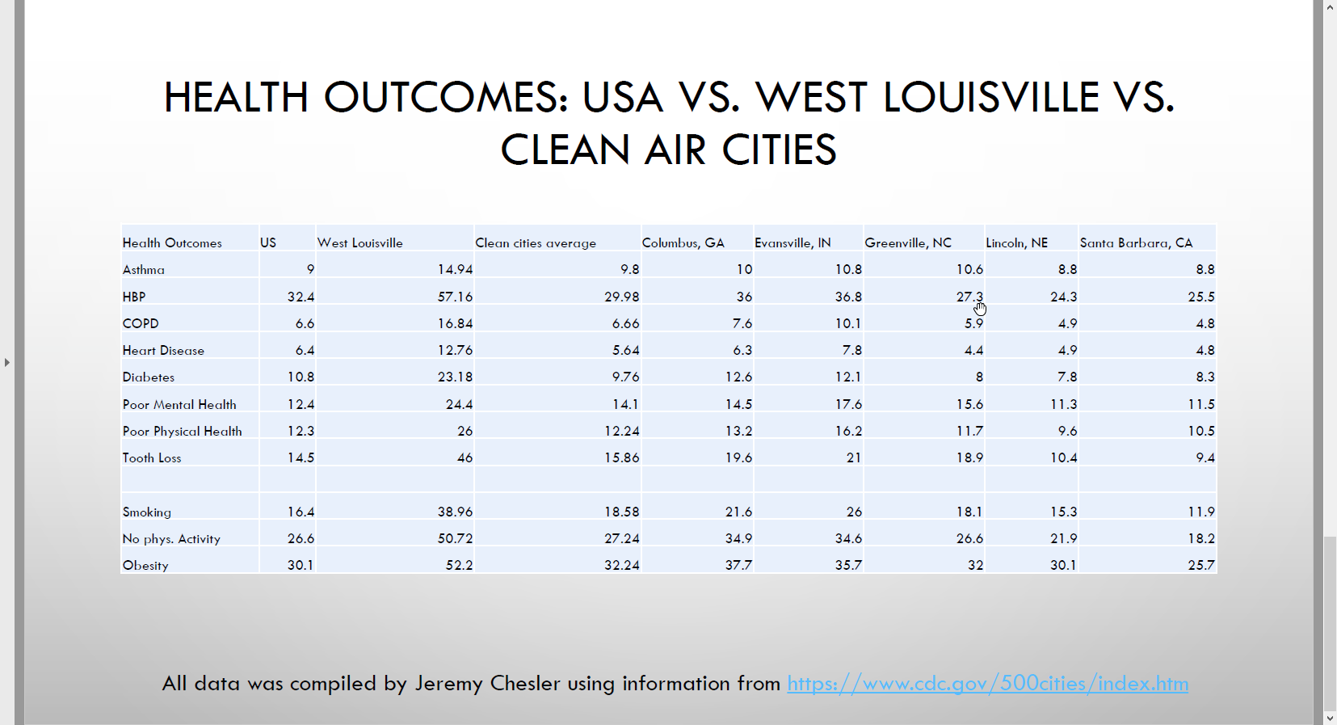
Source: Centers for Disease Control and Prevention https://www.cdc.gov/500cities/index.htm

Figure 1. Lancet Commission World Map Showing Concentrated Pollution Deaths
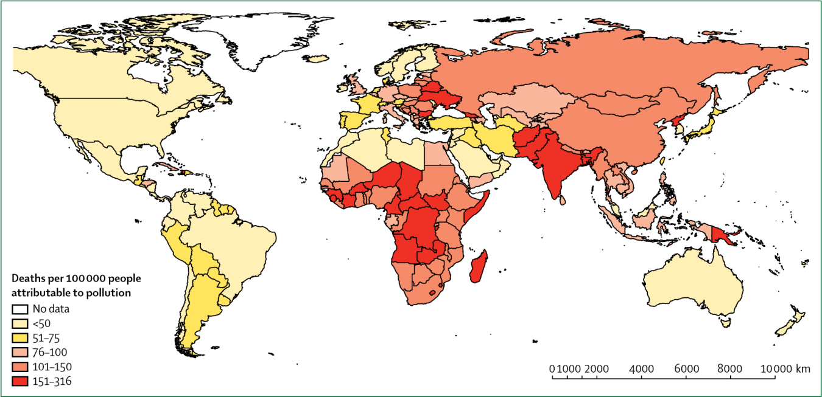
Source: Beelen, R. et al. (2014). Effects of long-term exposure to air pollution on natural-cause mortality: an analysis of 22 European cohorts within the multicentre ESCAPE project. The Lancet Vol. 383 No. 9919: 785-795. DOI: 10.1016/S0140-6736(13)62158-3.

Figure 2. Chetty’s 2014 Map of Shortened Lifespans Throughout the United States

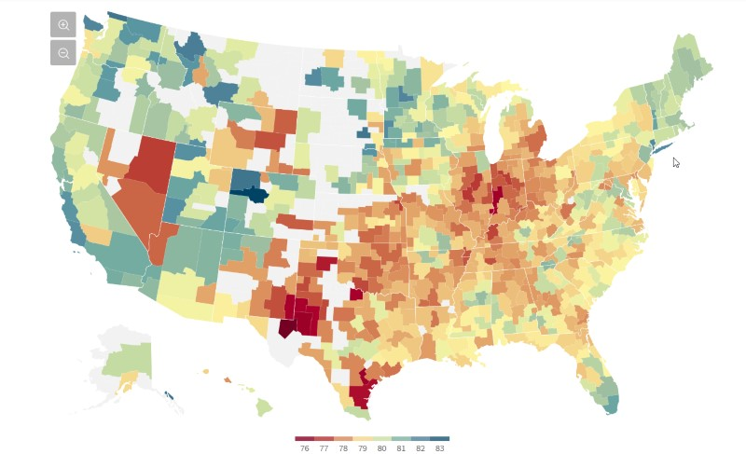

Source: Chetty, R., Cutler, D., Stepner, M., & Abraham, S. (2016). The Association Between Income and Life Expectancy in the United States; 2001-2014. Journal of the American Medical Association, 315 (16) pages 1, 750-1, 7666.

Figure 3. ProPublica Identified 1,000 Places with Dangerous Toxins

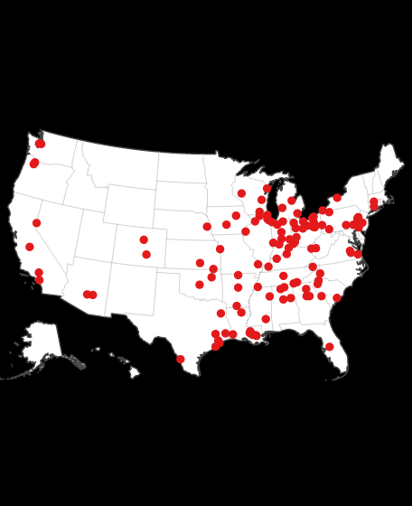
Source: Shaw, A., & Younes, L. (2021). The Most Detailed Map of Cancer-Causing Industrial Air Pollution in the US. ProPublica, November 2.

Figure 4. Chemical Exposure Action Map for USA
Source: Environmental Defense Fund, Collins & Proville, 2023
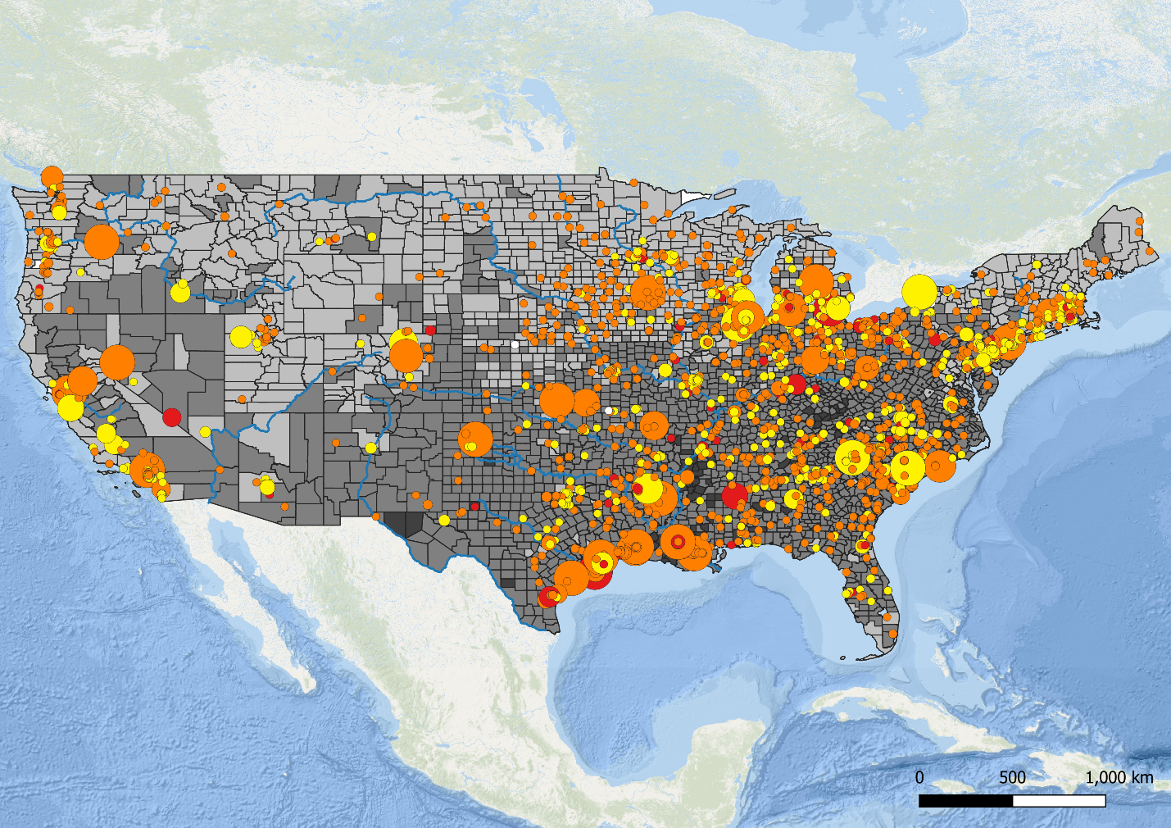

Number of Health Effects
(Asthma, Cancer, Developmental)
3 of 3
2 of 3
1 of 3
0 of 3

Climate Vulnerability Index
Very High
High
Medium
Low
Very Low

Chemical Releases
(2016-2020, millions of lbs.)
> 2.5
2.0 – 2.5
1.5 – 2.0
1.0 – 1.5
0.5 – 1.0
< 0.5

Figure 5. 148 semi-isolated, mid-sized U.S. cities

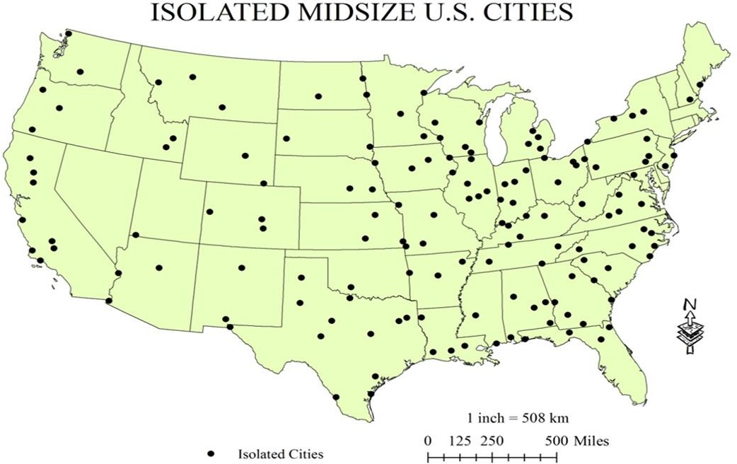

Source: Center for Sustainable Urban Neighborhoods, formerly University of Louisville, transferred to Neighborhood Associates, Washington, D.C.

Figure 6. Concentration of Chemical Industries in West Louisville Known as “Rubbertown”
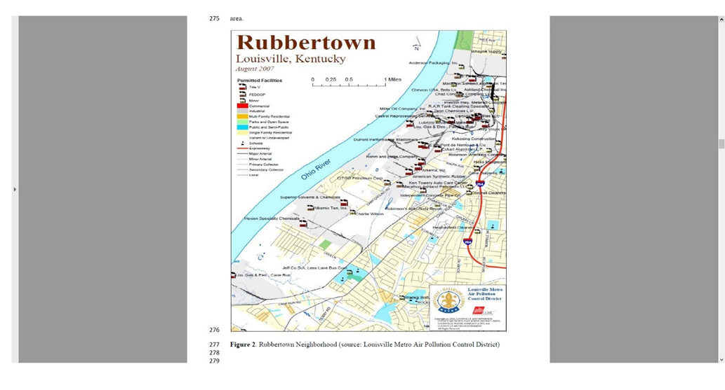
Source: Louisville Metro Air Pollution Control District

Figure 7. Pounds of toxic chemical releases in Louisville, Kentucky

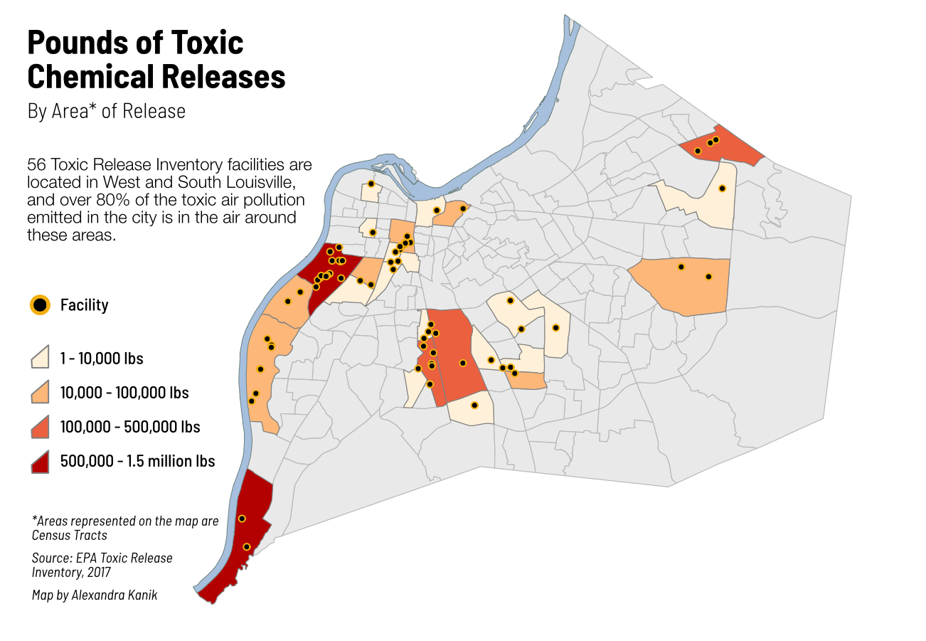

Source: EPA Toxics Release Inventory, 2017

Figure 8. Health Equity Life Expectancy in Louisville, Kentucky

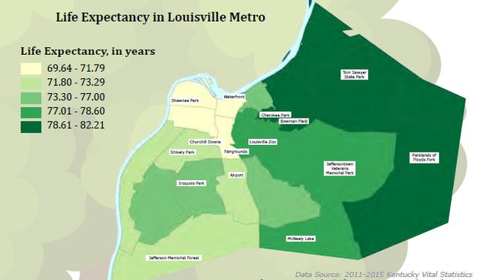
Source: 2011-2015 Kentucky Vital Statistics

Figure 9. Life Expectancies in Louisville, Kentucky

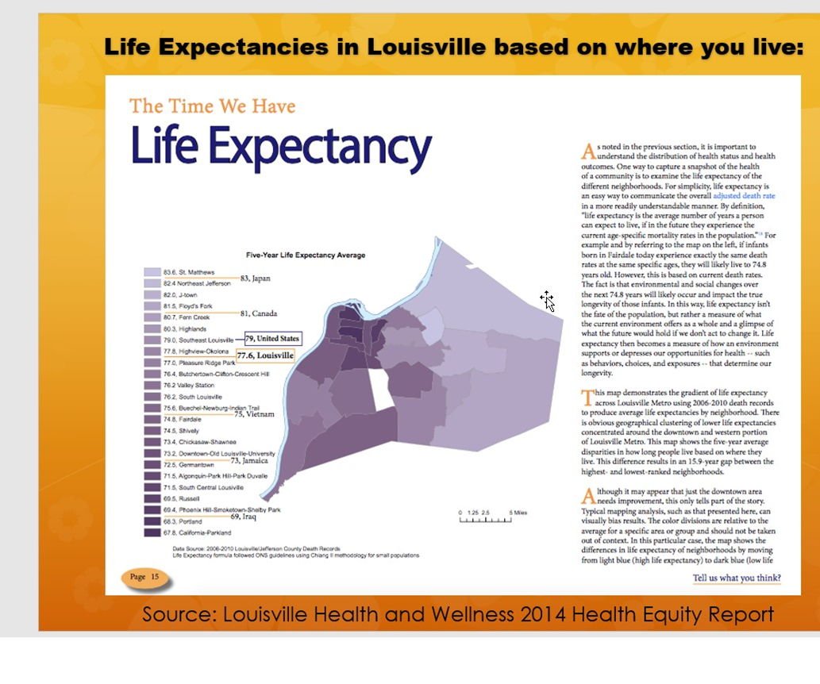
Source: Louisville Health and Wellness 2014 Health Equity Report
